1.Python program to implement a simple calculator
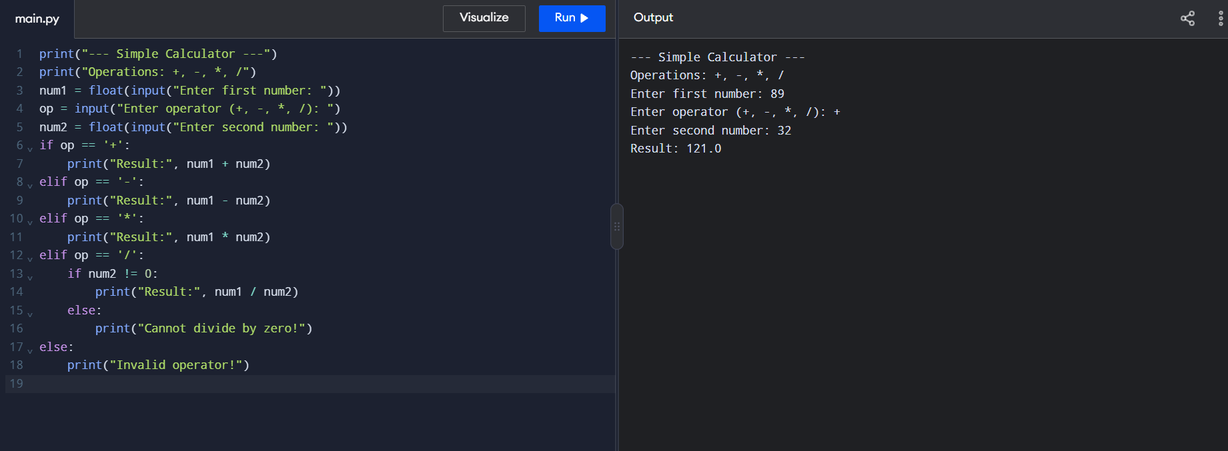
2.Python Program to implement a Add two Matrices
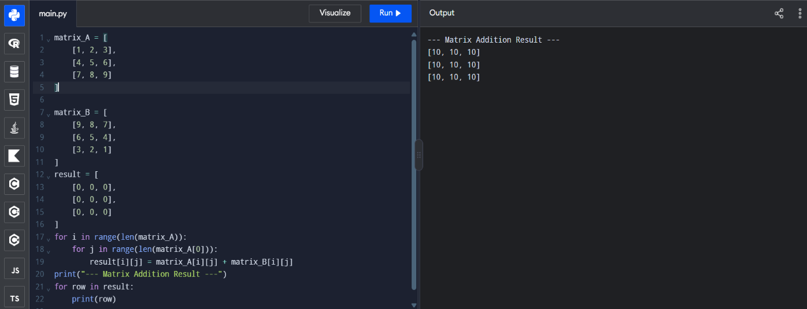
3.Python Program to Transpose a Matrix

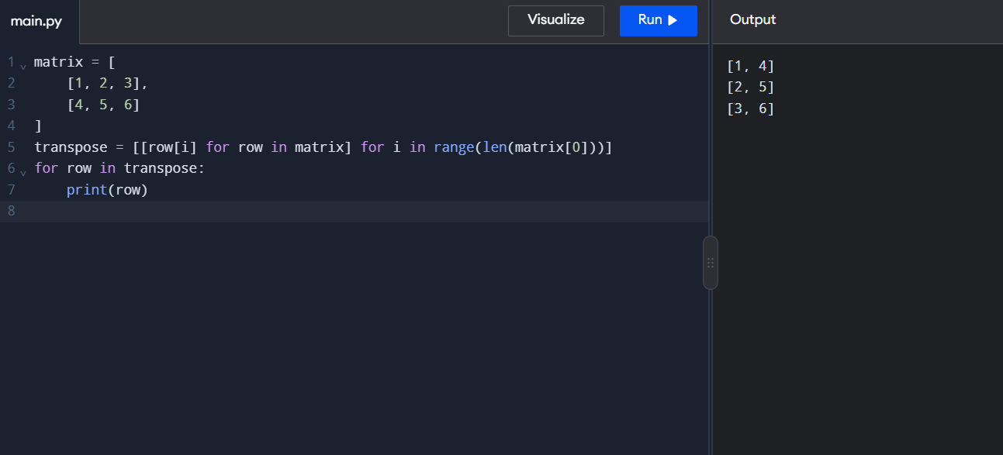
4.Python Program to sort the sentence in alphabetical order
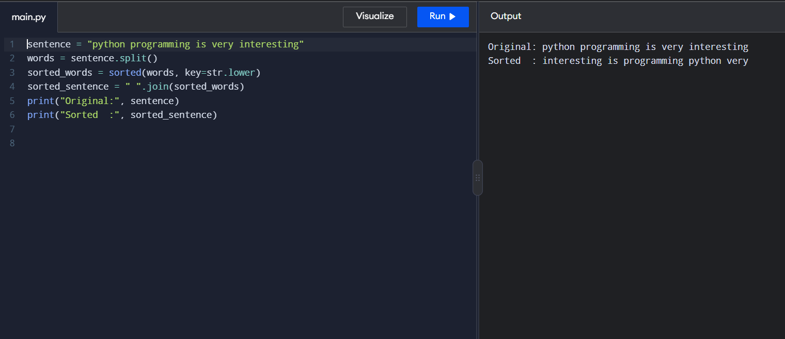
5.Python Program to implement List operation
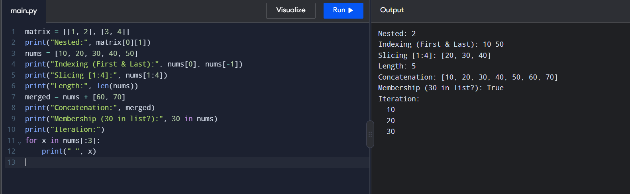
6.Python Program to implement List methods
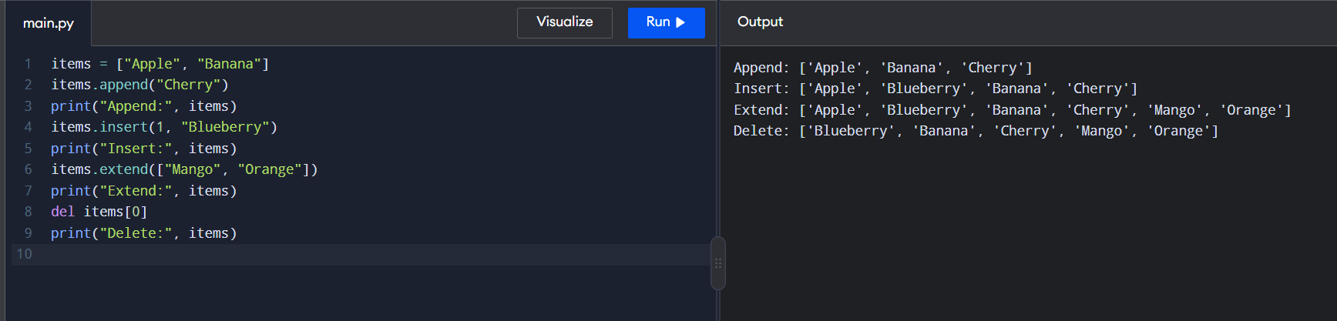

7.Python Program to Illustrate Different set Operation
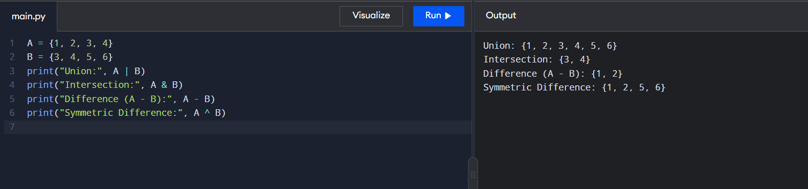

8.Python program to generate Calendar for the given month and year
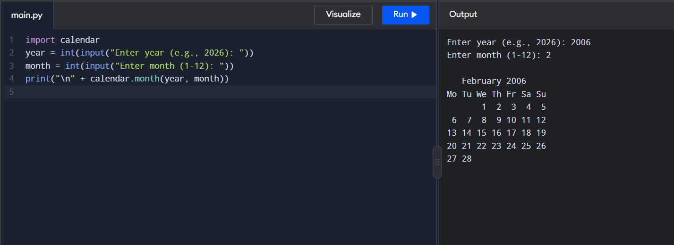
9.Python Program to remove punctuations from the given string
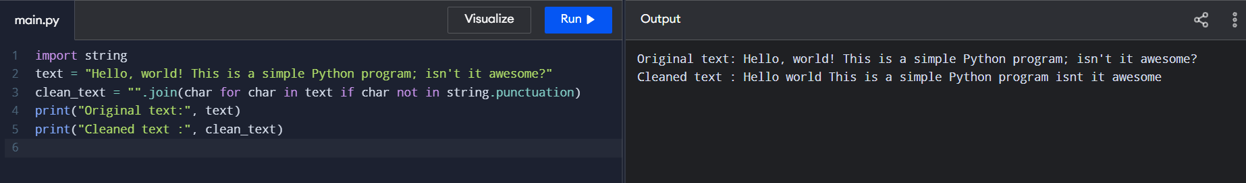

10.Python Program to solve 8-Puzzle problem
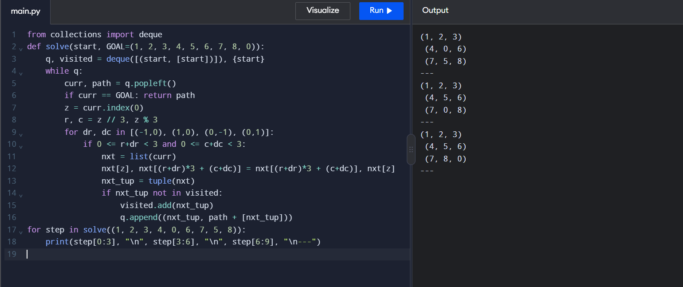

11.Python Program to solve 8-Queen problem
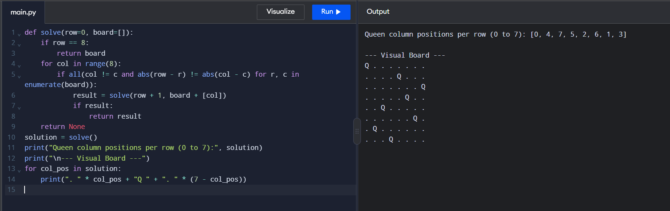

12.Python Program to implement BFS
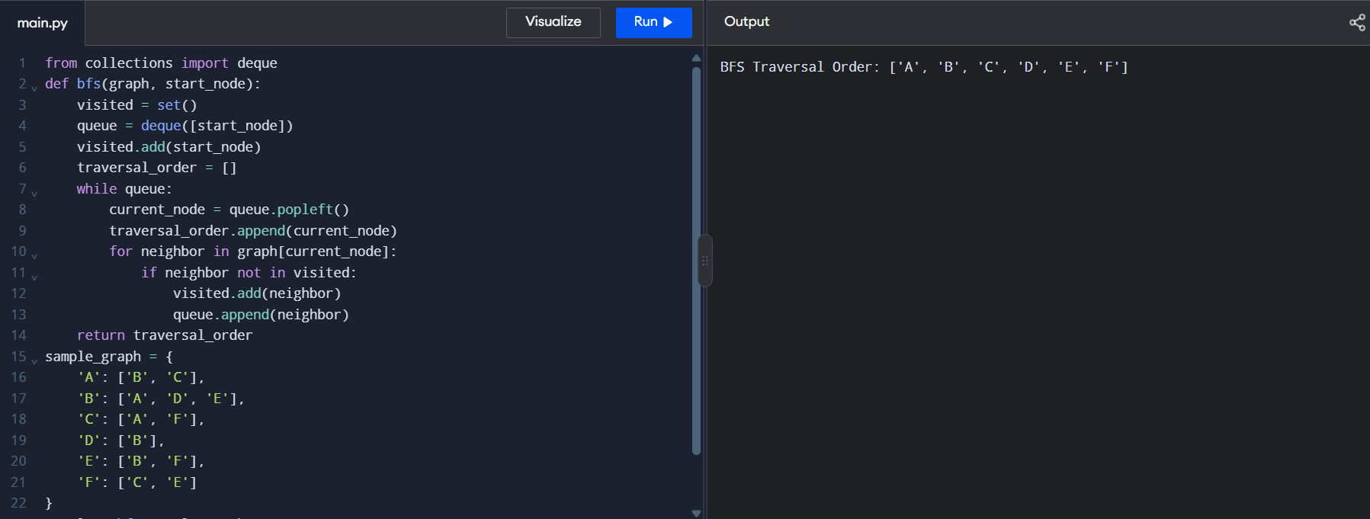
13. Python Program to implement DFS
